BOTVAULT
Software Requirements Specification
Final – As-Built
Field | Value
Project | BotVault – local trading-bot catalog and version vault
Authors | David & Jun
Course | CSC318
Purpose | Demonstrate understanding of the SDLC and software design principles
Document status | Final – written against the completed implementation
Document date | 2026-08-11

Table of Contents

1. Introduction

1.1 Purpose
This document specifies the requirements for BotVault, a Windows desktop application that acts as a local “vault” for a trader/developer's algorithmic trading bots. It records what the finished system does: the use cases it supports, the functional and non-functional requirements it satisfies, and the data model it persists to. It supersedes the original project proposal (the WHO/WHAT/WHY brief and hand-drawn diagrams produced at project kickoff) by describing the system as it was actually built, including several deliberate deviations from the original design that were made during implementation.

1.2 Scope
BotVault is a single-user, single-machine, offline desktop application. A user (trader or developer) can add a bot's source code file to a personal library, tag and search that library, keep a full version history of a bot's code as it evolves, attach backtest/performance documents to a bot, and export the entire library as a portable backup. BotVault has no server component, no network dependency, and no multi-user or multi-machine synchronization — all data lives on the machine BotVault runs on.

1.3 Definitions, Acronyms, and Abbreviations
Term | Definition
SRS | Software Requirements Specification (this document).
FR / NFR | Functional Requirement / Non-Functional Requirement.
Bot | A trading strategy: a source code file plus metadata (name, strategy type, version history, notes, status).
Head version | A bot's most recent version — the row in bot_version with the highest version_number for that bot.
SQLite | The embedded relational (SQL) database BotVault uses for bot metadata.
LMDB | “Lightning Memory-Mapped Database” — the embedded key-value (NoSQL) store BotVault uses for code and backtest document content.
SHA-256 | A cryptographic hash function that reduces any input bytes to a fixed-length 256-bit (64 hex character) digest; used here for integrity checking and content addressing (see §8.4).
Content-addressed storage | A storage scheme where an item's storage key is derived from (a hash of) its own content, rather than an arbitrarily assigned ID.
Dedup | Deduplication — storing identical content only once, detected here via matching SHA-256 hashes.
Backtest document | A file (report, spreadsheet, log, etc.) documenting a bot's simulated historical performance over some period.

2. Overall Description

2.1 Product Perspective
BotVault is a standalone desktop GUI application. It is not a component of a larger system, has no client-server split, and communicates with no external services. The application is built on CustomTkinter (a themed layer over Python's Tkinter) for the interface, and persists data using two embedded, file-based databases (SQLite and LMDB) that live entirely on the local disk.

2.2 Product Features
- Bot library: a searchable, sortable, filterable table of every bot the user has added.
- Version history: every code upload for a bot is retained as a numbered version, not overwritten.
- Status tagging: each bot's current version can be marked “in development”, “finished”, or “shelved”.
- Notes: a free-text note attached to each bot's current version.
- Backtest / performance tracking: arbitrary backtest documents can be attached to a bot, with period and note metadata.
- Strategy classification: bots are grouped under a strategy type (discretionary, forex, futures, …), which the user can extend.
- Integrity verification: every code read is checked against its recorded hash.
- Vault export: the whole library (database + code/document content) can be backed up to one zip file on demand.

2.3 User Classes and Characteristics
Actor | Description
Trader (User) | The primary user. Browses and searches the bot library, reviews a bot's status/notes/version history and backtest results, and reassigns a bot's status as it moves through development. Assumed comfortable with a desktop application but not necessarily a programmer.
Developer | Adds new bots and uploads new code versions as a strategy is written or revised, defines new strategy types, and attaches backtest documents after running simulations. May be the same individual as the Trader on a single-user installation, modeled as a separate actor because the actions (writing/uploading code) are conceptually distinct from the actions of reviewing/using a bot.

2.4 Operating Environment
- Operating system: Windows 10 or Windows 11 (64-bit).
- Runtime: Python 3 (developed/run under a Python 3.14 environment), with the customtkinter and lmdb packages installed (see requirements.txt).
- No internet connection or external service is required at any point.
- Launched via run_botvault.bat, which starts frontend/App.py using a known-good interpreter regardless of the working directory.

2.5 Design and Implementation Constraints
- Local-only persistence: no server, no cloud sync, no multi-machine access — declined by the project owner as out of scope (see §10).
- Single active writer: SQLite and LMDB are both accessed from the single Tkinter GUI thread; no concurrent-write handling is needed or implemented.
- Windows file dialogs (tkinter.filedialog) are the only mechanism for selecting files to import or export — there is no drag-and-drop or CLI interface.
- Application data is stored under the user's %LOCALAPPDATA%\BotVault folder, deliberately separate from the installed source tree.

2.6 Assumptions and Dependencies
- The user has write access to their own %LOCALAPPDATA% folder.
- Bot source files are provided as .py or .cs files (the file picker defaults to this filter but does not hard-block other extensions).
- The correctness of SHA-256 as a collision-resistant hash is relied upon for both integrity verification and content-addressed deduplication.

3. System Architecture
BotVault is organized into two top-level packages with a strict one-way dependency: the GUI (frontend/) calls into the backend (backend/) through a single facade class, and never touches the databases directly.

3.1 frontend/ — presentation layer
Module | Responsibility
App.py | Main window: table, toolbar, status bar, hotkeys (+ / add, / focus search, Delete remove row), row selection and double-click-to-detail.
dialogs.py | AddBotDialog — modal collecting bot name and strategy (with an inline “+ New Strategy” sub-form) after a file has been picked.
detail_dialog.py | BotDetailDialog — double-click popup: editable header (name/strategy), version history with Upload New Version / Export Code, and backtest list with Add / Export / Delete.
theme.py | Shared color palette, column layout, status-tag colors, and status-tag option list.

3.2 backend/ — persistence and business logic
Module | Responsibility
repository.py | BotRepository — the only module the GUI imports from. All bot/version/strategy/backtest business logic, transaction boundaries, and the write/delete ordering convention below live here.
sqlite_db.py | Opens the SQLite connection (WAL journal mode, foreign keys on), applies schema.sql, runs additive migrations, seeds default strategies.
lmdb_store.py | CodeStore — one LMDB environment with two named sub-databases (“code”, “backtest_docs”); put/get/delete plus a safe hot-backup copy.
hashing.py | sha256_bytes() — the single hashing entry point used for both integrity verification and content addressing.
config.py | Data-directory paths, status-tag list, LMDB sizing, seed strategy list.
exceptions.py | Domain error hierarchy (ValidationError, NotFoundError, IntegrityError, ExportError, StorageFullError) the GUI catches to show a friendly message instead of a crash.

3.3 Write / delete ordering convention
Throughout the backend, code and document content is written to LMDB before the SQLite row that references it is committed — so a crash mid-operation can at worst leave a harmless, unreferenced blob, never a database row pointing at data that was never saved. Deletes go the other way: the SQLite row is removed first, and only then is the now-unreferenced blob garbage-collected from LMDB, with a reference count check (since code blobs are content-addressed and may be shared by more than one bot).

4. Actors and Use-Case Model
The use-case diagram below is the original design sketch produced during project planning; every bubble it depicts that is in BotVault's scope (everything except the two “Provide Software/Feature Updates” extension points, which describe a future update-delivery mechanism explicitly out of scope for a local, offline application — see §10) was implemented. “Store Performance Metrics” was realized as backtest-document attachment (§5, UC-10) rather than structured performance columns — see the data-model deviation in §8.5.
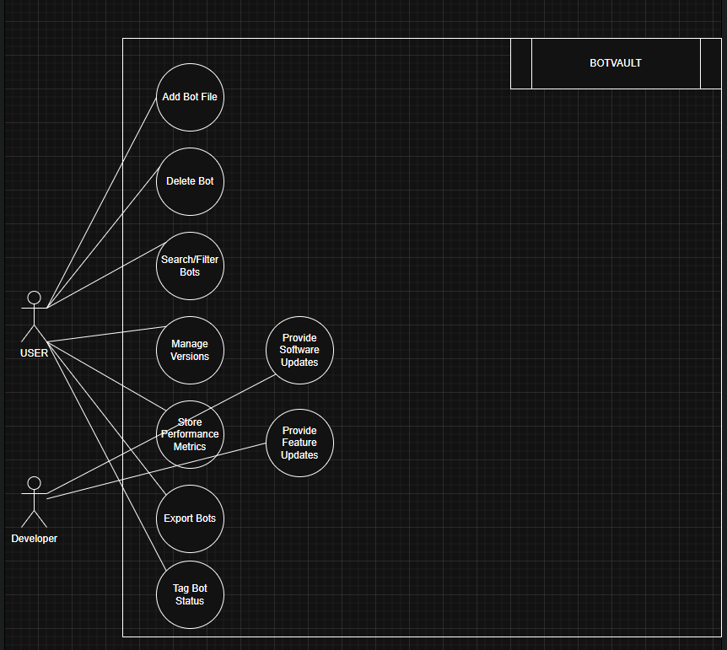
Figure 1. Actors and use cases (original design sketch).

5. Use Cases
UC-1 Add Bot File
Actor: Developer
Trigger: The user clicks “+ Add bot” (toolbar button or the + hotkey).
Preconditions: None.
Main flow:
- The user selects a .py/.cs source file via the OS file picker.
- BotVault opens the Add Bot dialog, pre-filling the bot name from the filename and defaulting the strategy to the first available strategy type.
- The user optionally edits the name, picks a different strategy, or chooses “+ New Strategy…” to define one inline.
- The user clicks Add.
- BotVault hashes the file (SHA-256), stores its bytes content-addressed in LMDB, and creates the bot plus its version 1 row in one SQLite transaction.
Postcondition: A new bot appears in the library table at version 1, status “in development”.
Alternate / exception flow: If the bot name is blank, or the chosen strategy is invalid, the dialog shows an inline error and no bot is created.
UC-2 Upload New Version
Actor: Developer
Trigger: The user opens a bot's detail popup (double-click a row) and clicks “Upload New Version”.
Preconditions: The bot already exists with at least one version.
Main flow:
- The user selects a replacement source file.
- BotVault hashes the new file.
- If the hash matches the bot's current head version, the upload is a silent no-op (no new version, no new storage write).
- Otherwise, a new head version is created with an incremented version number, carrying forward the previous head's status tag and resetting the note to blank.
Postcondition: The version history shows a new entry; the main table's VERSION/STATUS columns reflect the new head.
Alternate / exception flow: Uploading a file whose hash matches an older, non-head version (e.g. a deliberate revert) still creates a new head version rather than being treated as a duplicate.
UC-3 Export Code
Actor: Trader / Developer
Trigger: The user selects a version row in the detail popup and clicks “Export Code”.
Preconditions: At least one version exists and is selected.
Main flow:
- BotVault retrieves the code blob for the selected version and recomputes its SHA-256 hash.
- The recomputed hash is compared against the hash recorded at upload time.
- If they match, the user is prompted for a destination and the file is written back out with its original filename/extension restored.
Postcondition: The selected version's code is saved to a file on disk identical to what was originally uploaded.
Alternate / exception flow: If the recomputed hash does not match the recorded hash (corruption or tampering), an integrity error is shown and no file is written.
UC-4 Delete Bot
Actor: Trader / Developer
Trigger: The user selects a row and presses Delete (hotkey or confirmation dialog).
Preconditions: The bot exists.
Main flow:
- BotVault asks the user to confirm (“Remove this bot and all its versions?”).
- On confirmation, the bot's row is deleted, cascading to all its version and backtest rows.
- Every code hash and backtest document key the bot referenced is garbage-collected from LMDB, unless another bot's version still references the same code hash.
Postcondition: The bot no longer appears anywhere in the library; its exclusively-owned content is freed from storage.
Alternate / exception flow: Cancelling the confirmation dialog leaves the bot untouched.
UC-5 Search / Filter / Sort Bot Library
Actor: Trader / Developer
Trigger: The user types in the search box, changes the status filter, or clicks a column header.
Preconditions: None.
Main flow:
- The user types free text; results filter live on every keystroke, matching bot name or strategy name.
- The user optionally narrows results to a single status tag via the filter dropdown.
- The user clicks a column header to sort by that column; clicking the active column again reverses direction.
Postcondition: The table shows only the matching bots, in the chosen sort order, with an arrow indicating the active sort column and direction.
Alternate / exception flow: If no bots match, the table shows an explicit “no bots loaded” empty state instead of a blank table.
UC-6 Tag Bot Status
Actor: Trader / Developer
Trigger: The user changes the STATUS dropdown on a bot's row.
Preconditions: The bot exists.
Main flow:
- The user opens the status dropdown for a row and picks “in development”, “finished”, or “shelved”.
- BotVault writes the new status to the bot's current head version and repaints the row's status color.
Postcondition: The bot's status is updated and, if a status filter is active, the row may drop out of the current view.
UC-7 Edit Notes
Actor: Trader / Developer
Trigger: The user types into a bot's NOTES field and presses Enter, or clicks away.
Preconditions: The bot exists.
Main flow:
- The user edits the free-text notes box inline in the row.
- On Enter or on losing focus, BotVault saves the text to the bot's current head version.
Postcondition: The note is persisted; the table is not reloaded (so the user's focus/typing is never interrupted).
UC-8 Rename Bot / Reassign Strategy
Actor: Developer
Trigger: The user edits the name field or strategy dropdown in a bot's detail popup header and clicks Save.
Preconditions: The bot exists.
Main flow:
- The user edits the bot name and/or picks a different strategy in the detail popup header.
- The user clicks Save.
- BotVault updates only the fields that actually changed.
Postcondition: The bot's name and/or strategy are updated everywhere they are shown, including its full version history.
Alternate / exception flow: A blank name is rejected with an inline error and no change is saved.
UC-9 Create Strategy
Actor: Developer
Trigger: The user selects “+ New Strategy…” in the Add Bot dialog's strategy dropdown.
Preconditions: None (strategies are seeded by default, so this is optional, not required, for the first bot).
Main flow:
- The user types a strategy name and optional market type / description.
- On Add, BotVault creates the strategy (if the name is not already in use) and assigns it to the bot being created.
Postcondition: The new strategy is available for this and all future bots.
Alternate / exception flow: A blank or duplicate (case-insensitive) strategy name is rejected with an inline error.
UC-10 Add / Export / Delete Backtest Document
Actor: Developer / Trader
Trigger: The user clicks “Add Backtest”, “Export”, or “Delete” in a bot's detail popup.
Preconditions: The bot exists; for Export/Delete, a backtest row is selected.
Main flow:
- Add: the user picks a document file, then fills in optional start/end period and a note, and saves; the document is stored and listed.
- Export: the selected document's original bytes are written back out to a file chosen by the user, restoring its original filename.
- Delete: after confirmation, the selected document's row and stored content are removed.
Postcondition: The bot's backtest list reflects the addition, export, or removal.
Alternate / exception flow: Deleting a backtest does not require reloading the main library table, since no column there reflects backtest data.
UC-11 Export Vault
Actor: Trader / Developer
Trigger: The user clicks “Export Vault” in the toolbar.
Preconditions: None.
Main flow:
- The user chooses a destination .zip path (defaulted to botvault_export_YYYYMMDD.zip).
- BotVault backs up the live SQLite database via the Online Backup API (safe under WAL) and the live LMDB environment via its compacting hot-copy call, into a temporary staging directory.
- The staged files are zipped to a .part file, then atomically renamed to the chosen destination.
Postcondition: A single self-contained archive exists at the chosen path containing an exact snapshot of the vault's metadata and content.
Alternate / exception flow: If the destination directory is not writable, or the database is busy, the export fails with an explicit error and no partial file is left at the destination path.

6. Functional Requirements

6.1 Bot Library Management
ID | Requirement
FR-1 | The system shall allow a user to create a bot by selecting a source file, and specifying a bot name and strategy type.
FR-2 | The system shall compute a SHA-256 hash of a bot's code at upload time and store the code content-addressed, keyed by that hash.
FR-3 | The system shall create version 1 of a bot's history at creation time, defaulting its status to “in development”.
FR-4 | The system shall allow a user to delete a bot, cascading the deletion to its versions and backtests, and garbage-collecting any code/document content no longer referenced by any other bot.
FR-5 | The system shall allow a user to rename a bot and reassign it to a different strategy.

6.2 Version Management
ID | Requirement
FR-6 | The system shall allow a user to upload a new code version for an existing bot.
FR-7 | The system shall treat a re-upload whose hash matches the bot's current head version as a no-op (no new version row, no new storage write).
FR-8 | The system shall create a new head version, with an incremented version number, for any upload whose hash differs from the current head — including one that matches an older, non-head version.
FR-9 | The system shall retain and display a bot's full version history (version number, status, date, source filename, hash preview).
FR-10 | The system shall carry the previous head version's status tag forward onto a newly created version.
FR-11 | The system shall allow a user to export any historical version's code back to a file, restoring its original filename and extension.

6.3 Data Integrity
ID | Requirement
FR-12 | The system shall recompute a code blob's SHA-256 hash on every read and compare it to the hash recorded at upload time, raising an integrity error on mismatch instead of returning unverified data.

6.4 Strategy Management
ID | Requirement
FR-13 | The system shall allow a user to select an existing strategy or define a new one (name, market type, description) inline while adding a bot.
FR-14 | The system shall reject a new strategy whose name duplicates an existing one, case-insensitively.
FR-15 | The system shall seed a default set of strategy types (discretionary, non-discretionary, forex, futures, stocks) on first run.

6.5 Search, Filter, and Sort
ID | Requirement
FR-16 | The system shall allow a user to filter the bot library by a live text search over bot name and strategy name.
FR-17 | The system shall allow a user to filter the bot library to a single status tag.
FR-18 | The system shall allow a user to sort the bot library by name, strategy, status, version, or notes, ascending or descending.

6.6 Status and Notes
ID | Requirement
FR-19 | The system shall allow a user to tag a bot's current version as “in development”, “finished”, or “shelved”.
FR-20 | The system shall allow a user to attach a free-text note to a bot's current version.

6.7 Backtests / Performance Documents
ID | Requirement
FR-21 | The system shall allow a user to attach a backtest document to a bot, with optional start period, end period, and note.
FR-22 | The system shall allow a user to view, export, and delete a bot's backtest documents.

6.8 Export / Backup
ID | Requirement
FR-23 | The system shall allow a user to export the entire vault (metadata and content) to a single portable zip archive on demand.
FR-24 | The export shall use crash-safe backup mechanisms and write the destination archive atomically, so a failure never leaves a partial file at the chosen path.

6.9 Persistence
ID | Requirement
FR-25 | The system shall persist all bot/version/strategy/backtest metadata in a local relational database (SQLite).
FR-26 | The system shall persist all code and backtest document content in a local embedded key-value store (LMDB).
FR-27 | The system shall store all application data in the user's per-user application-data folder, independent of the installed source folder.

7. Non-Functional Requirements
ID / Category | Requirement | How it is satisfied
NFR-1  Performance | Searching the bot library returns results in well under 500 ms. | Search runs a single indexed SQLite query per keystroke; strategy, status, and version-history lookups are indexed (idx_bot_bot_name, idx_bot_strategy_id, idx_bot_version_bot_id_verdesc), and each bot's head version is computed once via a window function rather than one query per row.
NFR-2  Usability | A user can upload a bot with its code in 5 clicks or fewer. | Add bot → pick file → (name/strategy pre-filled with sensible defaults) → Add is a 3-click path from an idle state; the +, /, and Delete hotkeys shorten repeat operations further.
NFR-3  Integrity | Stored bots are verified against their hash. | Every code write is content-addressed by SHA-256 at write time, and every code read recomputes and compares that hash before returning the data, raising IntegrityError on any mismatch.
NFR-4  Portability | The application runs on Windows 10 and Windows 11. | Built entirely on cross-Windows-version technology (CustomTkinter/Tkinter, pure-Python SQLite/LMDB bindings); no OS-version-specific APIs are used.
NFR-5  Availability | The application is fully available without an internet connection. | All reads and writes are against the local filesystem; no network calls exist anywhere in the codebase.
NFR-6  Recoverability | A user can export the vault. | The “Export Vault” action snapshots SQLite (Online Backup API) and LMDB (compacting hot-copy) into one atomically-written zip file, usable to fully restore the vault on this or another machine.
NFR-7  Data safety | A crash or interruption during a write must never leave the database referencing missing or corrupt data. | Content is always written to LMDB before the SQLite row referencing it is committed; deletes remove the SQLite row first and only then garbage-collect now-unreferenced LMDB content, with a reference check for shared code blobs.

8. Data Model
The original entity-relationship sketch produced during project planning is shown below, followed by the schema as actually implemented (schema.sql) and a description of the content store and hashing scheme. §8.5 lists every point where the two differ and why.
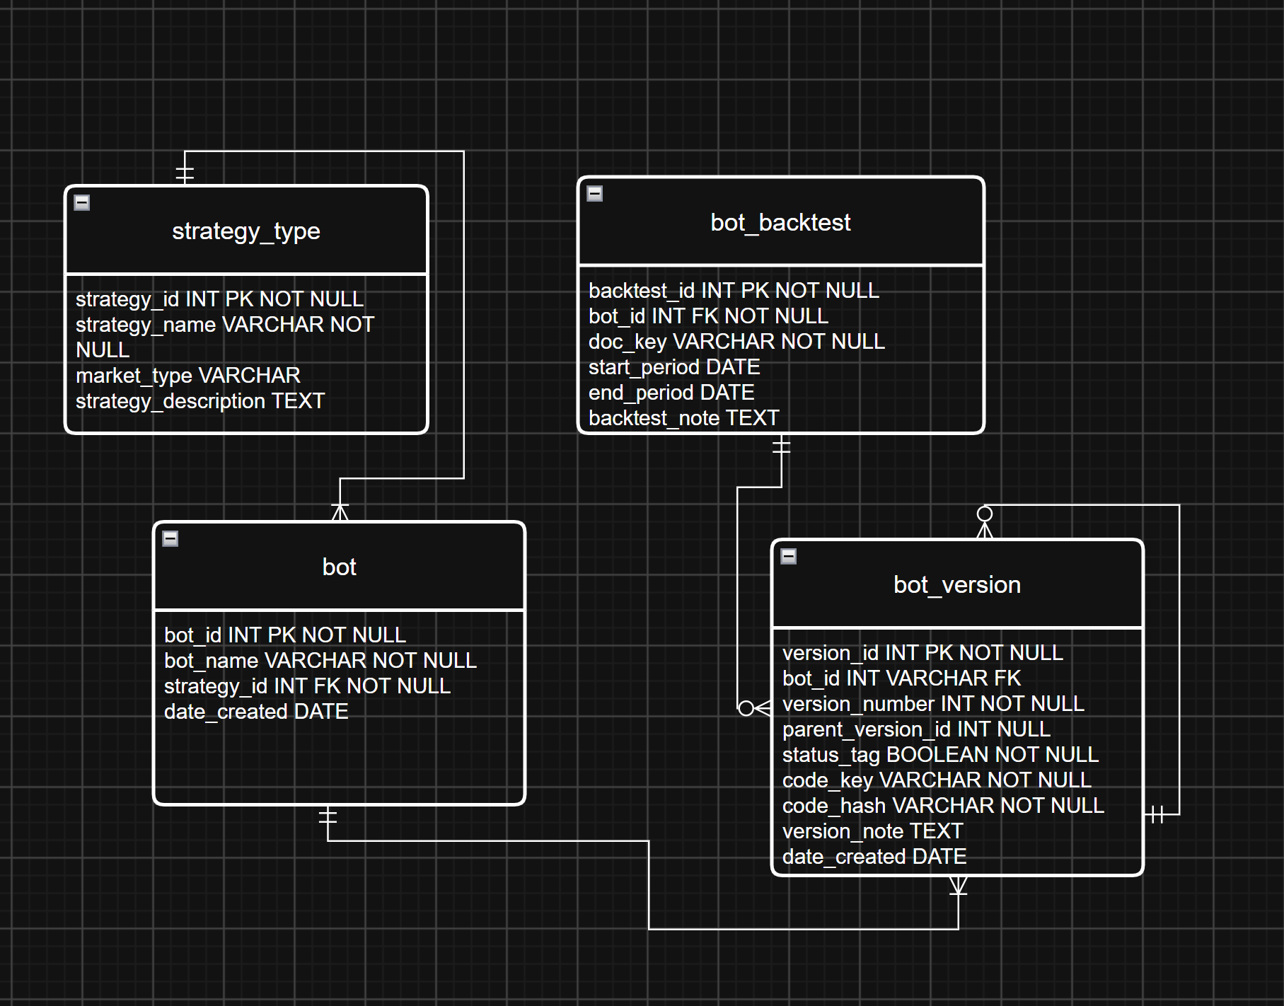
Figure 2. Original entity-relationship design sketch.

8.1 Relational Schema (SQLite)

strategy_type
Column | Type | Notes
strategy_id | INTEGER PK | Auto-assigned primary key.
strategy_name | TEXT NOT NULL UNIQUE | e.g. “forex”, “futures”; duplicates rejected case-sensitively at the DB level (case-insensitively at the UI level).
market_type | TEXT | Optional descriptive market classification.
strategy_description | TEXT | Optional free-text description.

bot
Column | Type | Notes
bot_id | INTEGER PK | Auto-assigned primary key.
bot_name | TEXT NOT NULL | Non-blank, enforced by a CHECK constraint.
strategy_id | INTEGER NOT NULL, FK → strategy_type
date_created | TEXT NOT NULL | ISO-8601 UTC timestamp, defaulted by SQLite.

bot_version
Column | Type | Notes
version_id | INTEGER PK | Auto-assigned primary key.
bot_id | INTEGER NOT NULL, FK → bot | ON DELETE CASCADE.
version_number | INTEGER NOT NULL | > 0; unique per (bot_id, version_number).
parent_version_id | INTEGER, FK → bot_version | Self-reference to the version this one replaced; NULL for version 1.
status_tag | TEXT NOT NULL | One of ‘in development’ / ‘finished’ / ‘shelved’, CHECK-constrained. See §8.5 (deviation #1).
code_key | TEXT NOT NULL | LMDB key in the “code” sub-database — equal to code_hash.
code_hash | TEXT NOT NULL | SHA-256 hex digest of the code; re-verified on every read (see §8.4).
source_filename | TEXT NOT NULL | Original filename; restores the correct extension on export. See §8.5 (deviation #4).
version_note | TEXT NOT NULL DEFAULT ‘’ | Free-text note, scoped to this version.
date_created | TEXT NOT NULL | ISO-8601 UTC timestamp.

bot_backtest
Column | Type | Notes
backtest_id | INTEGER PK | Auto-assigned primary key.
bot_id | INTEGER NOT NULL, FK → bot | ON DELETE CASCADE.
doc_key | TEXT NOT NULL | LMDB key in the “backtest_docs” sub-database — a fresh UUID4 per row, not content-addressed (§8.5, deviation #5).
source_filename | TEXT NOT NULL DEFAULT ‘’ | Restores the original extension on export.
start_period / end_period | TEXT | Optional descriptive date range for the backtest.
backtest_note | TEXT NOT NULL DEFAULT ‘’ | Optional free-text note.
date_created | TEXT NOT NULL | ISO-8601 UTC timestamp.
Indexes: idx_bot_bot_name, idx_bot_strategy_id, idx_bot_version_bot_id_verdesc, idx_bot_version_code_hash, idx_bot_backtest_bot_id — supporting the search, sort, and dedup-lookup access patterns above.

8.2 Content Store (LMDB)
A single LMDB environment (under %LOCALAPPDATA%\BotVault\botvault_lmdb, reserving up to 1 GiB of address space) holds two independent named sub-databases:
- code — bot source code, keyed by the SHA-256 hex digest of its bytes (content-addressed).
- backtest_docs — backtest documents, keyed by a freshly generated UUID4 per row (not content-addressed, since backtest outputs are unlikely to be byte-identical across runs).
Both sub-databases share the same put/get/delete pattern: writes use overwrite=False, so writing an already-present key is a safe, silent no-op — this is the mechanism that makes content-addressed code storage self-deduplicating for free.

8.3 SQLite vs. LMDB — why both
SQLite (a SQL / relational database) holds structured, queryable metadata: bot names, strategy classifications, version numbers, status tags, and dates — the fields the UI searches, filters, and sorts on. LMDB (a NoSQL / embedded key-value store) holds the large, opaque binary content — source code and backtest documents — that is only ever fetched whole by key, never queried by field. Both ship as small, dependency-light Python packages (sqlite3 in the standard library; the lmdb package) with no separate server process to install or run, which fits BotVault's fully local, zero-install operating model.

8.4 Hashing and Data Integrity
BotVault uses one hashing primitive throughout: SHA-256 (backend/hashing.py, sha256_bytes()), applied to the raw bytes of a bot's code (and, conceptually, applicable the same way to any stored blob). It serves two distinct purposes:
- Content addressing / deduplication — a code blob's LMDB storage key is its own SHA-256 hash. Two bots that happen to share identical code, or a bot re-uploaded with unchanged content, are stored exactly once: LMDB's overwrite=False write silently no-ops if that hash already exists. This is also what powers the version-upload dedup rule (FR-7/FR-8): a re-upload is recognized as “the same code” purely by comparing hashes, with no byte-by-byte diff required.
- Integrity verification — the hash computed at upload time is stored in bot_version.code_hash. Every time code is read back out (export, etc.), BotVault recomputes the SHA-256 of the retrieved bytes and compares it to that stored value. A mismatch means the blob was corrupted or altered after being written, and the read fails with an explicit IntegrityError rather than silently handing back bad data. This re-check on every read — not merely storing the hash at write time — is what satisfies NFR-3 (“stored bots are verified against hash”).
SHA-256 is a one-way cryptographic hash: it is computationally infeasible to find two different inputs that produce the same 64-character hex digest (collision resistance), and infeasible to reconstruct the original bytes from the digest alone (pre-image resistance). Those two properties are exactly what integrity checking and content addressing each depend on — a mismatch reliably signals “the bytes changed”, and a match reliably signals “these bytes are identical to something already stored”.

8.5 Deviations from the Original ERD
The following design decisions, made and confirmed during implementation, diverge from the original sketch in Figure 2:
- bot_version.status_tag was implemented as a TEXT enum (‘in development’ / ‘finished’ / ‘shelved’) rather than the original BOOLEAN, with a matching version_note field — both scoped to a bot's current head version, not the bot as a whole.
- The bot_performance table was removed entirely. Performance data lives inside backtest documents stored in LMDB (raw content) rather than structured SQL columns; bot_backtest (doc_key, start/end period, note) is kept as the pointer/metadata row.
- Dedup rule for re-uploading code: a hash match against the current head is a no-op; a hash match against an older, non-head version (an intentional revert) still creates a new head version.
- bot_version.source_filename was added (not in the original ERD) so the correct file extension can be restored when code is exported back out.
- Code is stored content-addressed (storage key = SHA-256 hash of the file bytes), giving free, correct dedup. Backtest documents are not content-addressed (a fresh UUID per row), since backtest documents are unlikely to be byte-identical across bots.
- Application data (the relational database and the code/document blob store) lives in the standard per-user application-data folder, not inside the project/source folder — keeping source and user data independent.
- strategy_type is seeded on first run (idempotent) with the example list from the original brief (discretionary, non-discretionary, forex, futures, stocks) so the first “Add bot” flow doesn't force the user to invent a strategy type immediately.

9. Verification and Acceptance
The following checks were performed against the completed implementation:
- Every backend module was syntax-checked and the application module loads cleanly with no import errors.
- An ad hoc backend test exercised, against a temporary database: strategy seeding, bot creation, search/filter, status and notes edits (including validation), version dedup on identical content, version bump and status carry-forward on different content, integrity-checked code retrieval, duplicate-strategy rejection, backtest create/list/get/delete, vault export (zip contents verified), bot deletion, and post-delete LMDB garbage collection — all passed.
- The GUI was launched headlessly and confirmed to start without error and to correctly create botvault.sqlite3 and botvault_lmdb\ on first run under %LOCALAPPDATA%\BotVault.
- The run_botvault.bat launcher was confirmed to start the application with the correct interpreter regardless of working directory.
Not yet exercised through manual, hands-on clicking at the time of writing: the full click-through of the Add Bot dialog (including the inline “+ New Strategy…” sub-form) and the Bot Detail dialog (upload new version, export code, add/delete backtest) — these were exercised via the repository layer directly rather than by clicking the live widgets, and are recommended for a final manual pass.

10. Out of Scope / Future Work
- Automatic or scheduled backup — declined by the project owner; Export Vault is a deliberate, manual, on-demand action only.
- An automated, repeatable test suite committed to the repository — verification in §9 used a throwaway script, not a maintained tests/ folder.
- Packaging or an installer (e.g. PyInstaller, MSIX) — the application currently runs from source via run_botvault.bat.
- A structured bot_performance table for querying/sorting metrics (sharpe, win rate, drawdown, …) in SQL — currently that data lives only inside opaque backtest documents; reintroducing this table would be needed to support SQL-level performance queries.
- Software/feature update delivery (the “Provide Software Updates” / “Provide Feature Updates” extension points in Figure 1) — not applicable to a fully offline, locally-run application.
- Multi-user access, network sync, or a server/cloud component of any kind.

11. Deployment / How to Run
One-time setup (installs the two required packages, customtkinter and lmdb):
python -m pip install -r requirements.txt
Every subsequent run:
run_botvault.bat
Application data lives at %LOCALAPPDATA%\BotVault\. Deleting a bot's original source file after adding it to BotVault is safe, since the code is copied into botvault_lmdb\ at upload time and never read from the original path again. Losing the %LOCALAPPDATA%\BotVault\ folder (or the machine) loses everything unless Export Vault (§6.8, UC-11) has already been used to back the data up elsewhere — there is no cloud or server component.

